

Game Price Search Tool

Project Group Members: Ding Liao, Zest, Jason, Zhuoyan Liu

INFO 200 | AE Group 5 | Locksley Kolakowski

Table of Contents

**Low-Fidelity Wireframing Stage (~200 words)** **3**

**Moodboard (optional)** **3**

**Design Language / Style Guide** **4**

Font 4

Colors 4

**High-Fidelity Wireframes** **5**

[Onboarding](https://docs.google.com/document/d/1IpGH1rQyj-MEK7bqDUvG7KhhT0bS6vT9zXEbCZWyhMw/edit#heading=h.xsxqaigc69t7) [6](https://docs.google.com/document/d/1IpGH1rQyj-MEK7bqDUvG7KhhT0bS6vT9zXEbCZWyhMw/edit#heading=h.xsxqaigc69t7)

Usage Scenario 1 7

Usage Scenario 2 8

Usage Scenario 3 (optional) 9

[**Interactive Prototype**](https://docs.google.com/document/d/1IpGH1rQyj-MEK7bqDUvG7KhhT0bS6vT9zXEbCZWyhMw/edit#heading=h.x3i3yk1yhv8k)[**9**](https://docs.google.com/document/d/1IpGH1rQyj-MEK7bqDUvG7KhhT0bS6vT9zXEbCZWyhMw/edit#heading=h.x3i3yk1yhv8k)

**Bibliography** **9**

**Appendix** **10**

Now that you've done a draft design and received some feedback on it, your last deliverable for this project is to put together a high-fidelity prototype of your solution. In this document you will be adding in the high-fidelity wireframes of your solution and a link to the interactive prototype of your solution. Below we have listed the elements of the Project Final Prototype which should be present in the document. Please take 10 minutes out to read through it carefully.

Please Note: You are not required to actually build a working version of your solution, you may do that instead, but a prototype is all that is required.

You should already have these ready from the past few project deliverable you have completed. You may need to make small updates but that is it.

* Personas *(Optional to include)*: Justify your personas. Who was your main focus? Are there any additional personas?
* [Solutions Considered](https://docs.google.com/document/d/1IpGH1rQyj-MEK7bqDUvG7KhhT0bS6vT9zXEbCZWyhMw/edit#heading=h.jj3xpku87bvb)
* Selected Solution
* Description of your solution
* Product Features
* Sitemap (optional)
* Low-Fidelity Wireframes

**PLEASE GO TO THE NEXT PAGE**

# 

# Low-Fidelity Wireframing Stage

Our first prototype receives quite good feedback. However, it does have drawbacks to provide a more comfortable interaction with users; for instance, although the chosen design style is cool, some texts can appear to be hard to recognize and read. We learn that a UI layout should not only look good but also make sense to its audiences. Therefore, we choose to change the font colors and provide a background color to the paragraphs, which can more clearly showcase the information as well as emphasize those important news.

In addition, our first interaction fails to produce a logical user journey map, where buttons messed up to show their functionalities. A button with a microphone vector illustration misleads users to think of it as a voice input function. However, we mean to design it to change the volume of the application. In addition, it makes no sense to always show this button in the very left bottom corner of all screens. We just initially think about designing this feature for those devices which don’t have an external button to control the volume. Therefore, we re-design this feature by adding a setting screen where users can configure their own options for those cool features.

# Moodboard

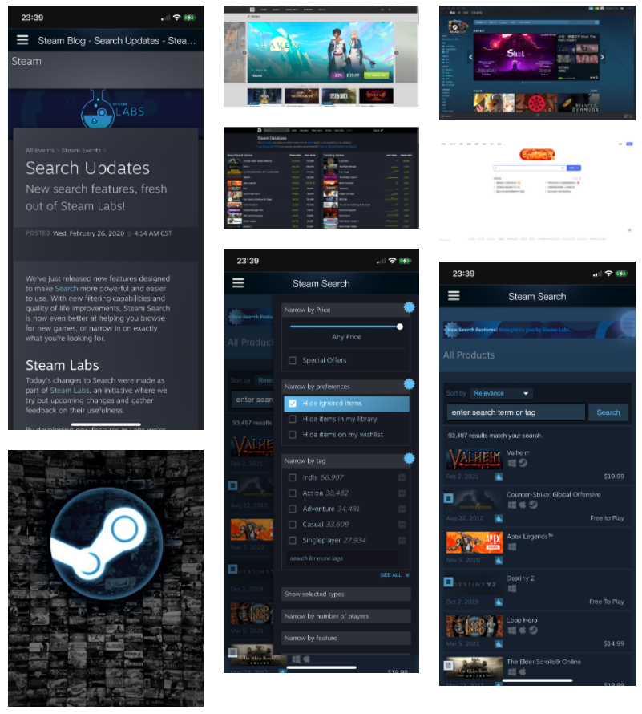

Our Moodboard: **http://www.gomoodboard.com/boards/zgybFGol/share**

## Font

The font we are using is “Roboto”. This font makes more sense for those audiences who are used to the electronic devices and interact with a great variety of applications, just like those who prefer “Time New Roman” fonts in academic papers and newspapers as well. The design fashion of this font is more commonly seen in various prevailing websites and forums.

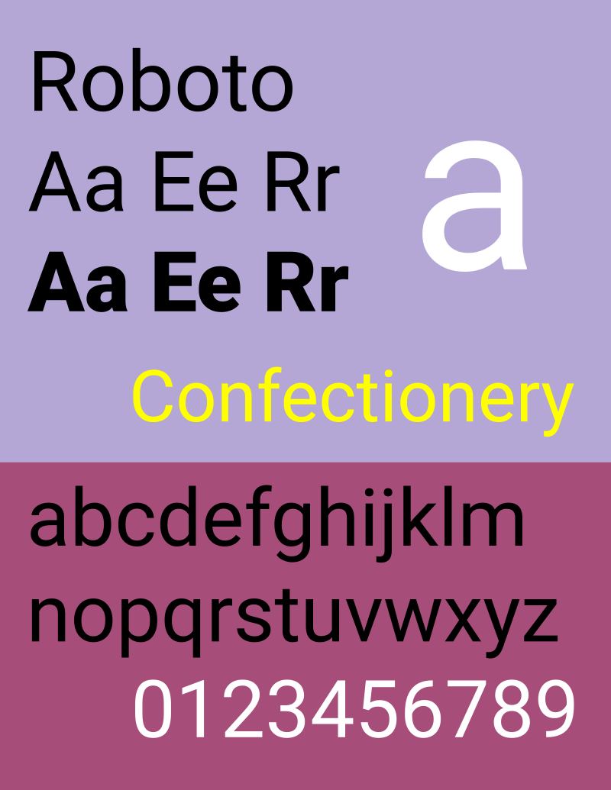

https://en.wikipedia.org/wiki/Roboto#/media/File:Roboto_Font_Sample.svg

## Colors

We choose to use a brown overall background with purple title texts and while paragraph texts of a grey filling background as our main color design style. This design would make the application to be more welcomed by those game players, who are used to the deep color design in their daily gaming usage. In addition, the contrast between brown and white would emphasize the contents of information, especially having a purple color design of titles. Users would be more likely to recognise the layout of information and thus discover the materials they are looking for.

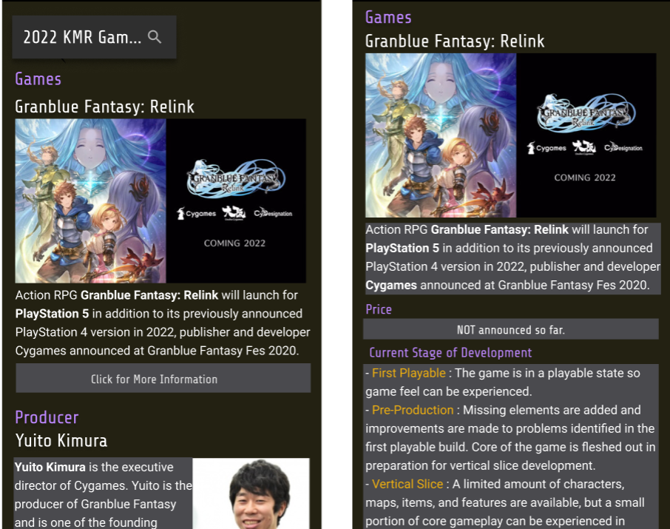

# High-Fidelity Wireframes

# Onboarding

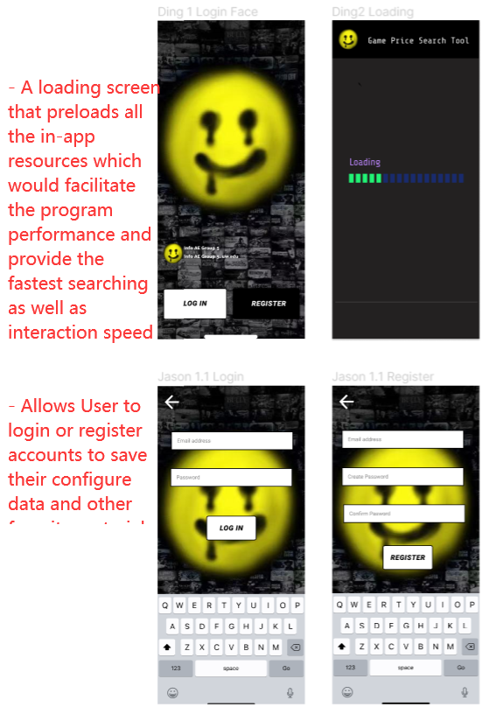

Usage Scenario 1

Log in, Loading, and Home Screen

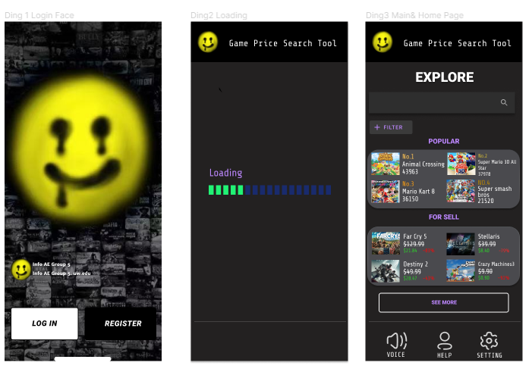

The login page permits users to use different social media accounts, google accounts, or created GPST accounts to get access.

The loading page gave the flexibility of waiting for responses to pages or applications.

The home page contains a voice over function that can help people with disabilities to use our tool. The help button aside can help with users with any existing problems. Every user will be assigned with stuff that helps them respectively. The last button is a setting which can make changes of voice over and front size.

## 

## Usage Scenario 2

Search Bar and Search Results

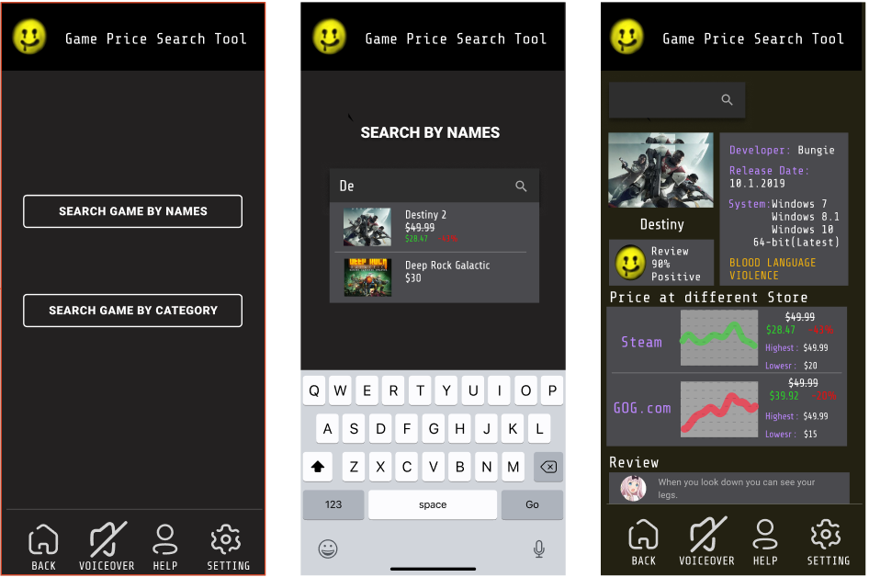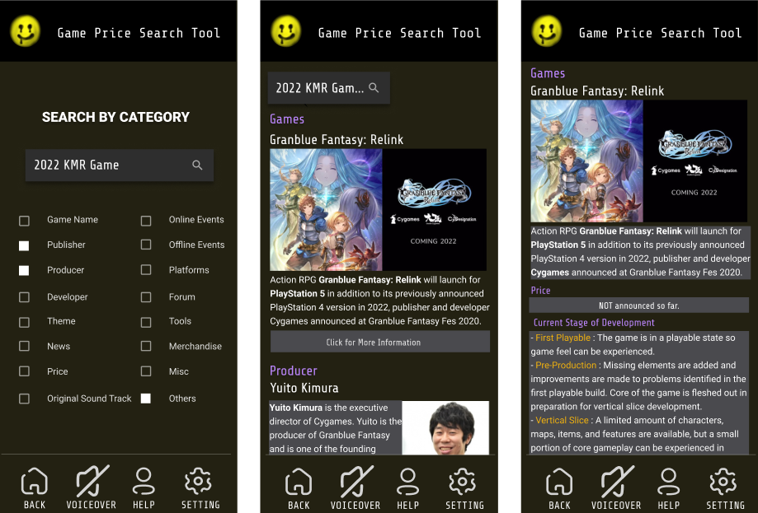

The main search page allows users to select the way they want to find their targets.

The Search by Names page depends more on users’ familiarity to a game, while Search by Category page does not.

Selecting a game will provide users not only the price condition, but also some extra information about their targeting games.

User Journey Map

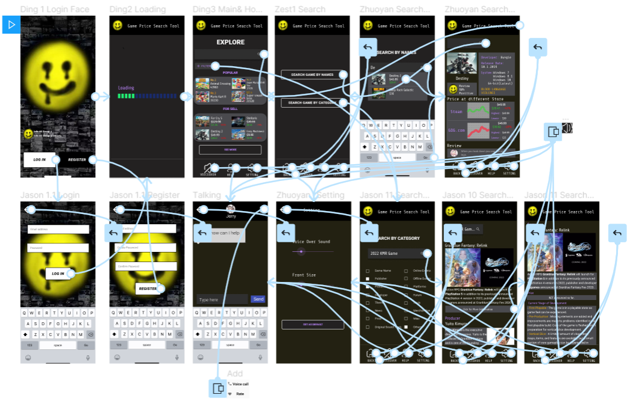

# Interactive Prototype

Please check our prototype made by Figma via this link: <https://www.figma.com/proto/VZUGUUPTGWNX1WUj9dL68I/Game-Price-Search-Tool?node-id=10%3A133&scaling=scale-down>

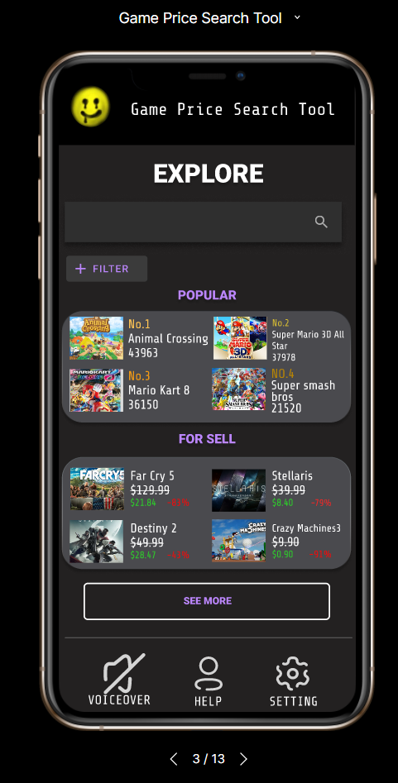

# 

# References

You may refer to some white paper documents or websites while explaining some of the design decisions you have made. You are required to reference them and provide the citations at the end of the document.

# Appendix

Include any reference images, user research notes, and additional project material in your appendix. The appendix is a great place to include all your project images and scans of your design process.

**Formatting Guidelines:**

* Font: Size 12 - Helvetica, Arial, Roboto, etc.
* Include page numbers in the footer.
* Table of contents
* Margins: Normal - 1 inch
* Caption all images. Provide a figure or label for each.
* Annotate all diagrams and wireframes and provide a legend if necessary
* **SAVE AND SUBMIT THE DOCUMENT AS A PDF.**

**If you are creating a website or an application check out these websites:**

* [material.io/guidelines/](http://s.bl-1.com/h/Z7xJFoh?url=http://material.io/guidelines/): Android Material Design Guidelines
* [https://developer.apple.com/ios/human-interface-guidelines/](http://s.bl-1.com/h/Z7xJKBk?url=https://developer.apple.com/ios/human-interface-guidelines/): iOS Design Guidelines
* [http://findguidelin.es/](http://s.bl-1.com/h/Z7xKpZx?url=http://findguidelin.es/): Brand Guidelines of Popular Tech Companies
* [ui-patterns.com/patterns](http://s.bl-1.com/h/Z7xJQbm?url=http://ui-patterns.com/patterns)
* [Mobile-patterns.com](http://s.bl-1.com/h/Z7xJVzo?url=http://mobile-patterns.com)
* [https://pttrns.com/](http://s.bl-1.com/h/Z7xJZNq?url=https://pttrns.com/)
* [http://mobiledesign.com/](http://s.bl-1.com/h/Z7xKgns?url=http://mobiledesign.com/)
* [https://blog.figma.com/18-designers-predict-ui-ux-trends-for-2018-2d04d41361c6](http://s.bl-1.com/h/Z7xKvyz?url=https://blog.figma.com/18-designers-predict-ui-ux-trends-for-2018-2d04d41361c6)

All the best. That was a lot to read, I know!

Please email your TA if you have any additional questions.